MPI COLLECTIVE COMMUNICATIONS LAB
NAME: ABHINAV SINGH BHAGTANA
ROLL NO: 29
SECTION: A
REG NO: 230905225

Q1.write MPI program to read n values in the root process. Root process sends one value to each process. Every process receives it and finds the factorial of that number and returns it to the root process. Root process gathers the factorial and finds the sum of it. Use N number of processes.

#include <mpi.h>
#include <stdio.h>

int fact(int n)
{
int p = 1;
for(int i = 2; i <= n;i++)
p*=i;
return p;
}

int main(int argc,char *argv[])
{
int rank,size;
MPI_Init(&argc,&argv);
MPI_Comm_rank(MPI_COMM_WORLD,&rank);
MPI_Comm_size(MPI_COMM_WORLD,&size);

int n, array[size];
if(rank == 0)
{

printf("enter %d values: ",size);
for(int i = 0;i < size;i++)
scanf("%d",&array[i]);
}
MPI_Scatter(array,1,MPI_INT,&n,1,MPI_INT,0,MPI_COMM_WORLD);
n = fact(n);
MPI_Gather(&n,1,MPI_INT,array,1,MPI_INT,0,MPI_COMM_WORLD);
if(rank == 0)
{
int sum = 0;
for(int i = 0;i < size;i++)
sum+=array[i];
printf("process 0 has calculateds sum: %d\n",sum);
}
MPI_Finalize();
return 0;
}
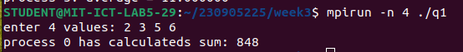
Q2.Write an MPI program to read an integer value M and NxM elements into a 1D array in the root process, where N is the number of processes. Root process sends M elements to each process. Each process finds average of M elements it received and sends these average values to root. Root collects all the values and finds the total average. Use collective communication routines.
#include <mpi.h>
#include <stdio.h>

double average(double *arr,int size)
{
double avg = 0;
for(int i = 0;i < size;i++){
avg += arr[i];
}
return (double)avg/size;
}
int main(int argc,char **argv)
{
int rank,size;
MPI_Init(&argc,&argv);
MPI_Comm_size(MPI_COMM_WORLD,&size);
MPI_Comm_rank(MPI_COMM_WORLD,&rank);

int m;
if(rank == 0) {
printf("enter m: ");
//fflush(stdout);
scanf("%d",&m);
}

MPI_Bcast(&m, 1, MPI_INT, 0, MPI_COMM_WORLD);

double recvarr[100] = {0};

if(rank == 0) {
double array[size*m];
printf("enter %d elements: \n", size*m);
for(int i=0; i<size*m; i++)
scanf("%lf", &array[i]);
MPI_Scatter(array, m, MPI_DOUBLE, recvarr, m, MPI_DOUBLE, 0, MPI_COMM_WORLD);
} else {
MPI_Scatter(NULL, m, MPI_DOUBLE, recvarr, m, MPI_DOUBLE, 0, MPI_COMM_WORLD); // Non-root recv
}

printf("process %d recieved numbers:\n",rank);
for(int i = 0;i < m;i++)
printf("%f\n",recvarr[i]);

double avg = average(recvarr, m);
printf("process %d: average = %f\n",rank,avg);

MPI_Gather(&avg, 1, MPI_DOUBLE, recvarr, 1, MPI_DOUBLE, 0, MPI_COMM_WORLD);

if(rank == 0) {
double final_avg = average(recvarr, size);
printf("Process 0 calculates average: %f\n", final_avg);
}
MPI_Finalize();
return 0;
}
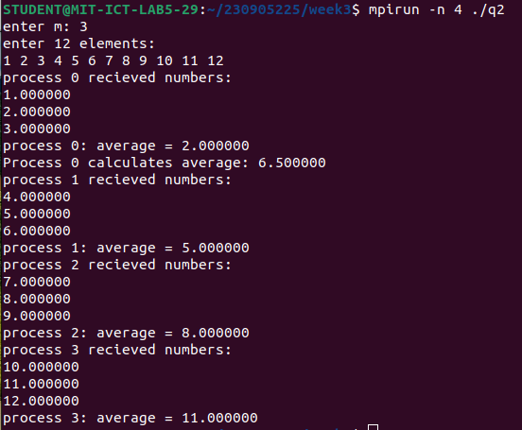

Q3.Write an MPI program to read a string. Using N processes find the number of non-vowels in the string. In the root process print number of non-vowels found by each process and printf the total number of non-vowels.

#include <mpi.h>
#include <stdio.h>
#include <string.h>
#include <ctype.h>
#include <stdlib.h>

int is_vowel(char c) {
c = tolower(c);
return (c == 'a' || c == 'e' || c == 'i' || c == 'o' || c == 'u');
}

int main(int argc, char** argv) {
int rank, size;
char full_string[100];
int n; // string length

MPI_Init(&argc, &argv);
MPI_Comm_rank(MPI_COMM_WORLD, &rank);
MPI_Comm_size(MPI_COMM_WORLD, &size);

if (rank == 0) {
printf("Enter a string (length divisible by %d): ", size);
scanf("%s", full_string);
n = strlen(full_string);
}

// Broadcast string length to calculate chunk size
MPI_Bcast(&n, 1, MPI_INT, 0, MPI_COMM_WORLD);
int chunk_size = n / size;
char *local_str = (char*)malloc(sizeof(char) * chunk_size);

// Distribute chunks of the string to all processes
MPI_Scatter(full_string, chunk_size, MPI_CHAR, local_str, chunk_size, MPI_CHAR, 0, MPI_COMM_WORLD);

// Count non-vowels in the local chunk
int local_non_vowels = 0;
for (int i = 0; i < chunk_size; i++) {
if (isalpha(local_str[i]) && !is_vowel(local_str[i])) {
local_non_vowels++;
}
}

// Gather all local counts into an array in the root process
int *all_counts = NULL;
if (rank == 0) {
all_counts = (int*)malloc(sizeof(int) * size);
}

MPI_Gather(&local_non_vowels, 1, MPI_INT, all_counts, 1, MPI_INT, 0, MPI_COMM_WORLD);

// Root process displays results
if (rank == 0) {
int total_non_vowels = 0;
printf("\n--- Results ---\n");
for (int i = 0; i < size; i++) {
printf("Process %d found %d non-vowels.\n", i, all_counts[i]);
total_non_vowels += all_counts[i];
}
printf("Total number of non-vowels: %d\n", total_non_vowels);
free(all_counts);
}

free(local_str);
MPI_Finalize();
return 0;
}
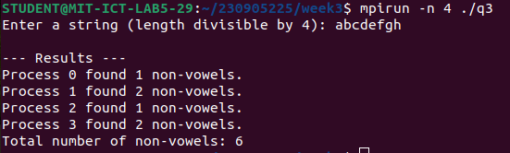
Q4.Write an MPI program to read two strings S1 and S2 of same length in the root process. Using string as show below. Display the resultatnt string the root process. Use collective communication routines.
#include <mpi.h>
#include <stdio.h>
#include <stdlib.h>
#include <string.h>

int main(int argc, char **argv)
{
MPI_Init(&argc, &argv);

int rank, size;
MPI_Comm_rank(MPI_COMM_WORLD, &rank);
MPI_Comm_size(MPI_COMM_WORLD, &size);

int L = 0; // string length
char *S1 = NULL, *S2 = NULL;

if (rank == 0)
{
char a[1024], b[1024];
printf("Enter S1: ");
fflush(stdout);
scanf("%1023s", a);
printf("Enter S2: ");
fflush(stdout);
scanf("%1023s", b);

L = (int)strlen(a);
if ((int)strlen(b) != L)
{
printf("Error: lengths differ\n");
MPI_Abort(MPI_COMM_WORLD, 1);
}
if (L % size != 0)
{
printf("Error: length not divisible by N\n");
MPI_Abort(MPI_COMM_WORLD, 1);
}

S1 = malloc(L + 1);
S2 = malloc(L + 1);
strcpy(S1, a);
strcpy(S2, b);
}

MPI_Bcast(&L, 1, MPI_INT, 0, MPI_COMM_WORLD);

int chunk = L / size;
char *local1 = malloc(chunk);
char *local2 = malloc(chunk);

// Scatter chunks of both strings
MPI_Scatter(S1, chunk, MPI_CHAR, local1, chunk, MPI_CHAR, 0, MPI_COMM_WORLD);
MPI_Scatter(S2, chunk, MPI_CHAR, local2, chunk, MPI_CHAR, 0, MPI_COMM_WORLD);

// Build local interleaved output (size = 2*chunk)
char *localOut = malloc(2 * chunk);
for (int i = 0; i < chunk; i++)
{
localOut[2 * i] = local1[i];
localOut[2 * i + 1] = local2[i];
}

// Gather localOut blocks to root
char *result = NULL;
if (rank == 0)
result = malloc(2 * L + 1);

MPI_Gather(localOut, 2 * chunk, MPI_CHAR,
result, 2 * chunk, MPI_CHAR, 0, MPI_COMM_WORLD);

if (rank == 0)
{
result[2 * L] = '\0';
printf("Resultant String: %s\n", result);
}

free(local1);
free(local2);
free(localOut);
if (rank == 0)
{
free(S1);
free(S2);
free(result);
}

MPI_Finalize();
return 0;
}
